Git & Git Hub
To check if git is already installed and is of which version.
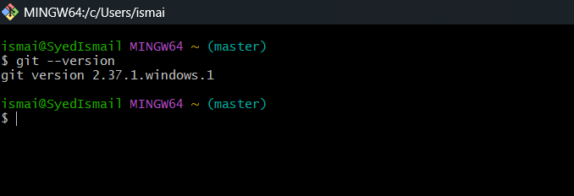

To initialize and create a new empty directory with .git extension
git init
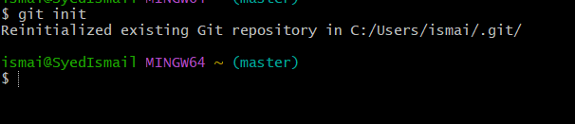

To check the changes in the directory we use command
git status
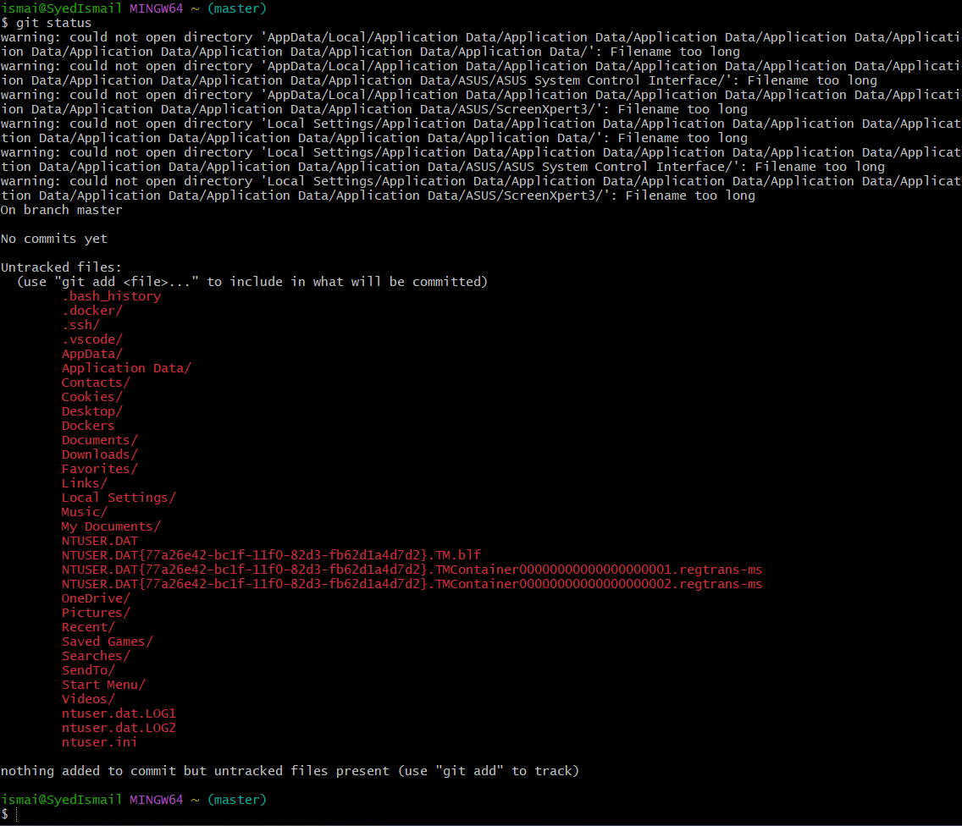

To list the initialized files, we use ls -a command
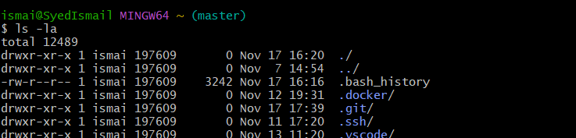
Cd .git/ it is a directory created after initializing and is consists of configurations related things
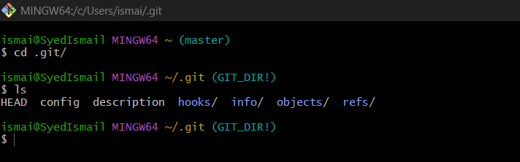

To get all the details about git use command
first we use to get username
git config –global user.name Syed Ismail pasha
second we use to get email id
git config –global user.email syedismailpasha451@gmail.com
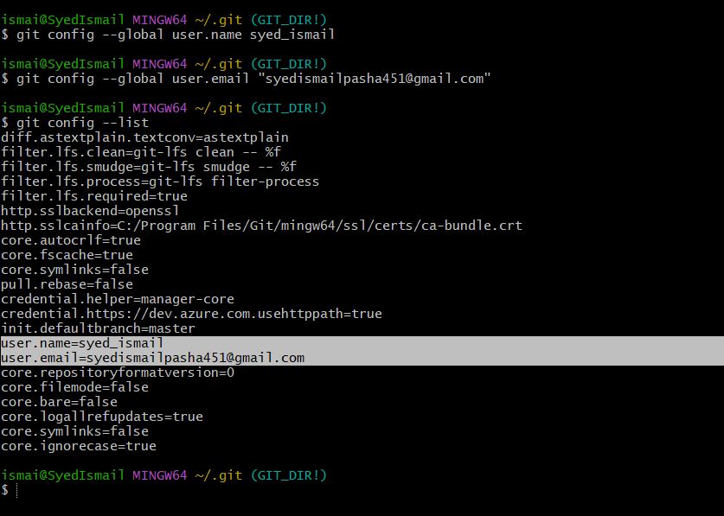

In order to push the file to central repository, we need to move files
from untracking area to tracking area.
git add filename
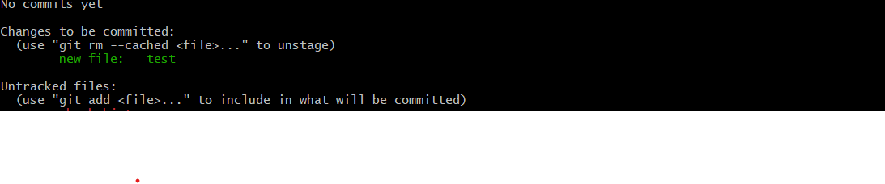
To add all files from untracked files to tracked files we use command
git a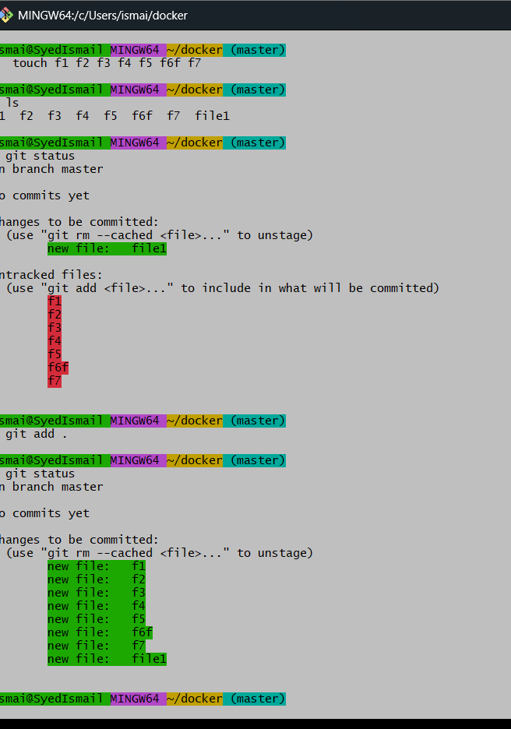
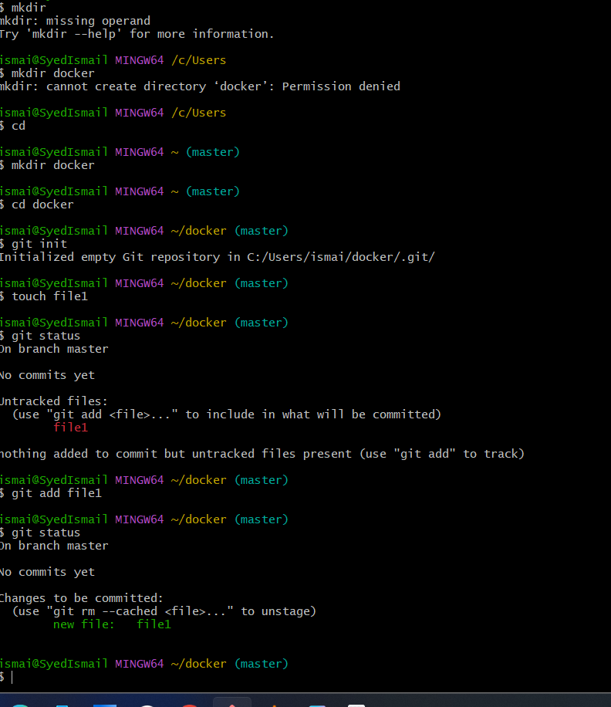

All the files have been moved to the tracking area.
To store the files in central repository we should commit
git commit -m “added couple of files to each folder”
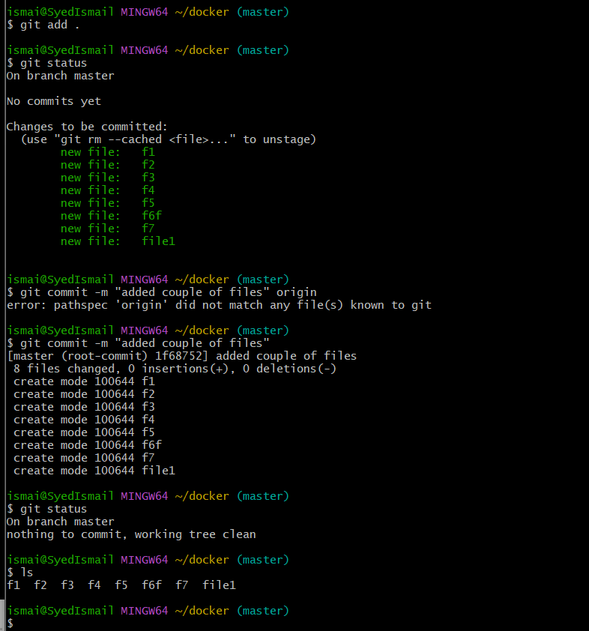
To see complete commit id details use command
git log ---- it will show complete details about commit id
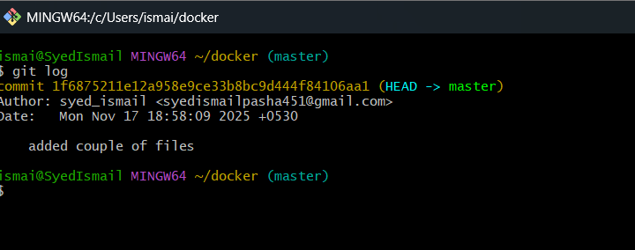

It will show number of commits you have added with commit
messages.

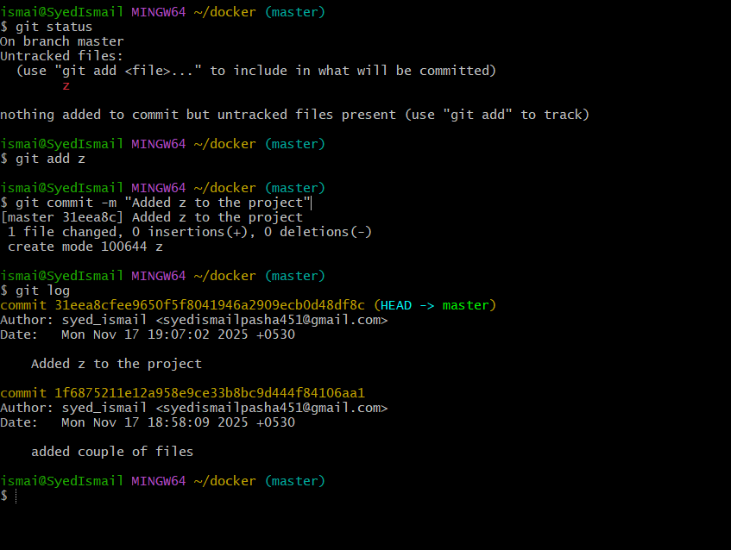

For every commit a unique commit id is generated.
To push your file to git hub we need to create new repository
+new ---- repository name ---- description(optional)

To add my file to repository in git hub use command
git remote add origin ssh <pate url here>
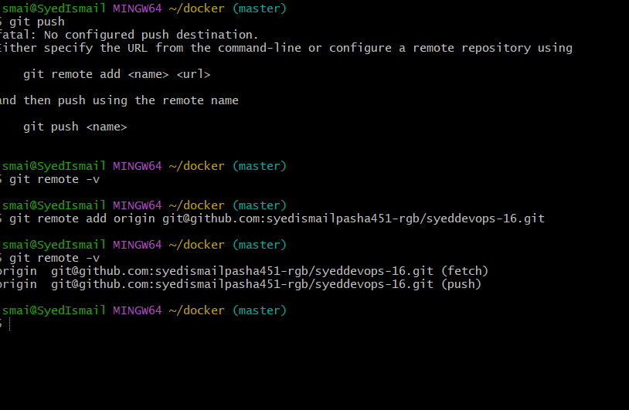

Here we can see some addresses are configured.
To connect with the remote server for github we need to provide key pair

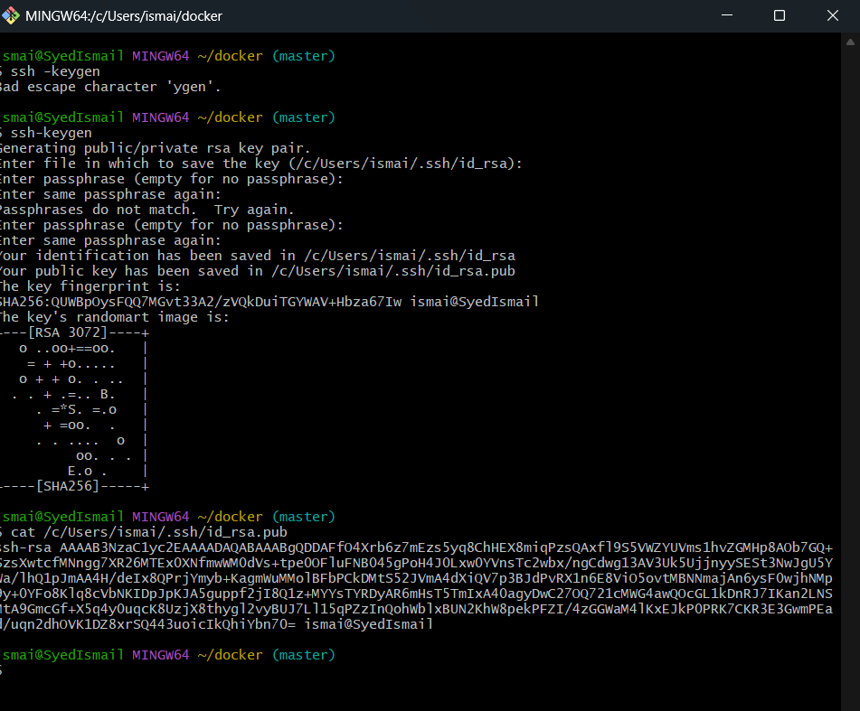

then we need to go to
git hub ---- settings ---- SSH and GPG keys ---- add ssh key

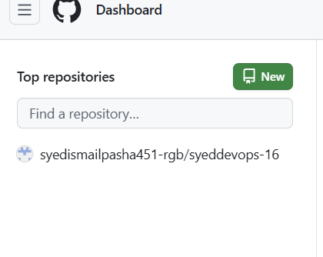

To push the file to the git hub repository we use command
git push -u origin master
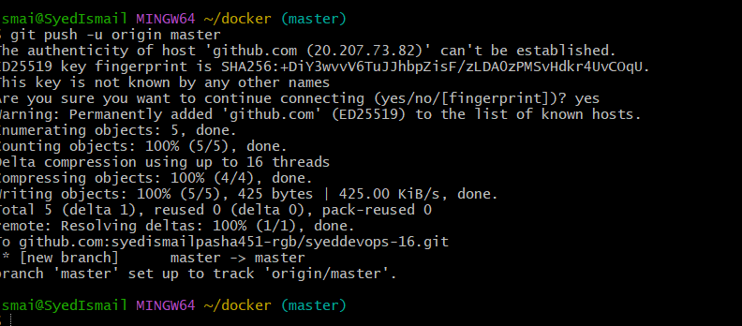

If I will open docker-files then it show all the content or files in it
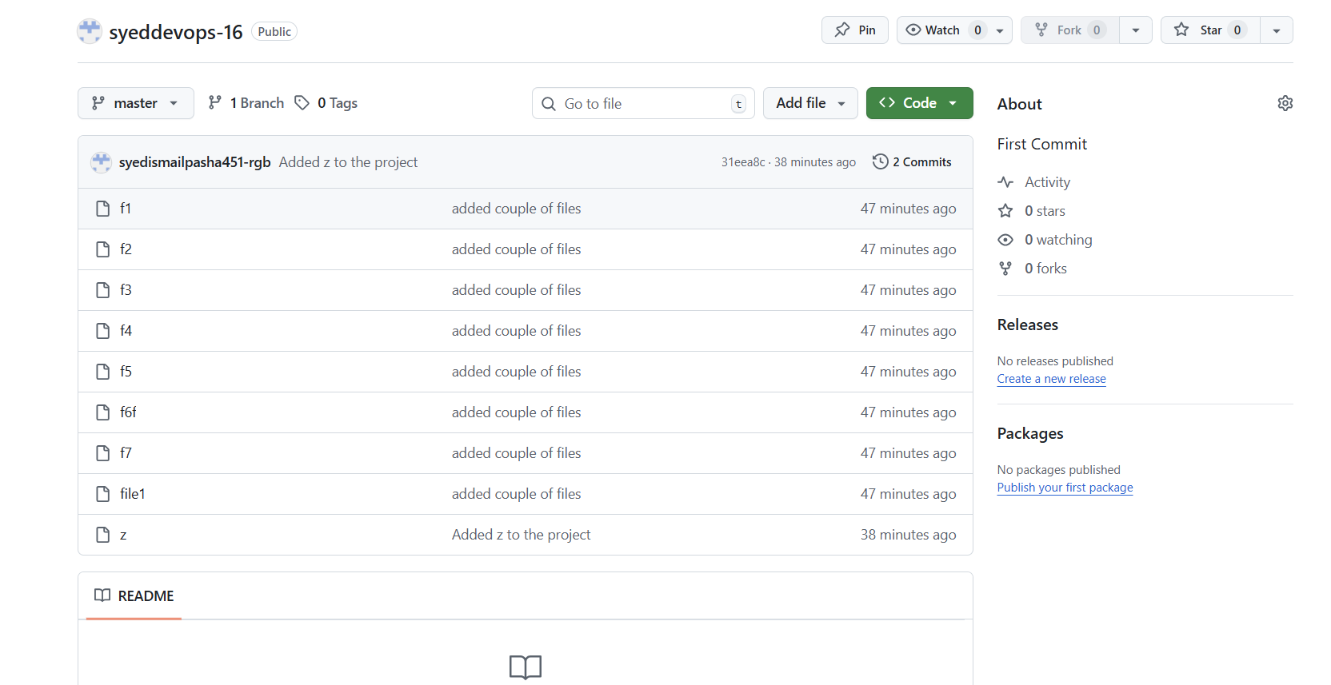

Now if I want to delete any file from the git hub repository

rm -rf f4
git status
git add .
git commit -m “deleted f4”
git push -u origin master

